Business Hours

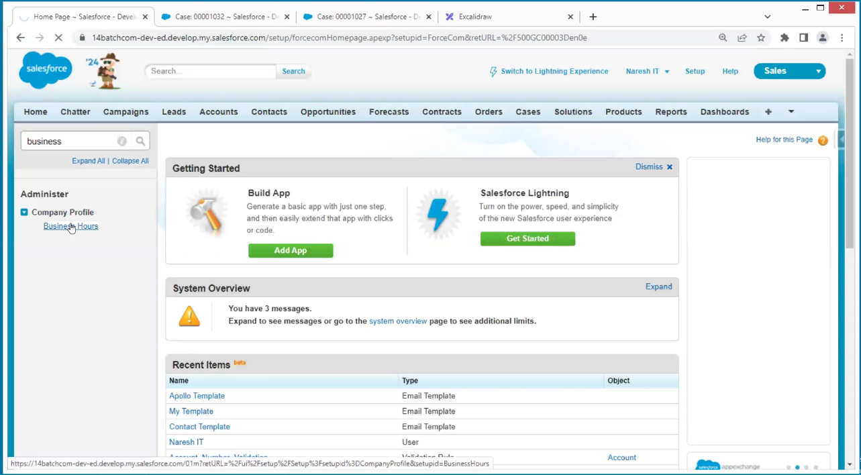

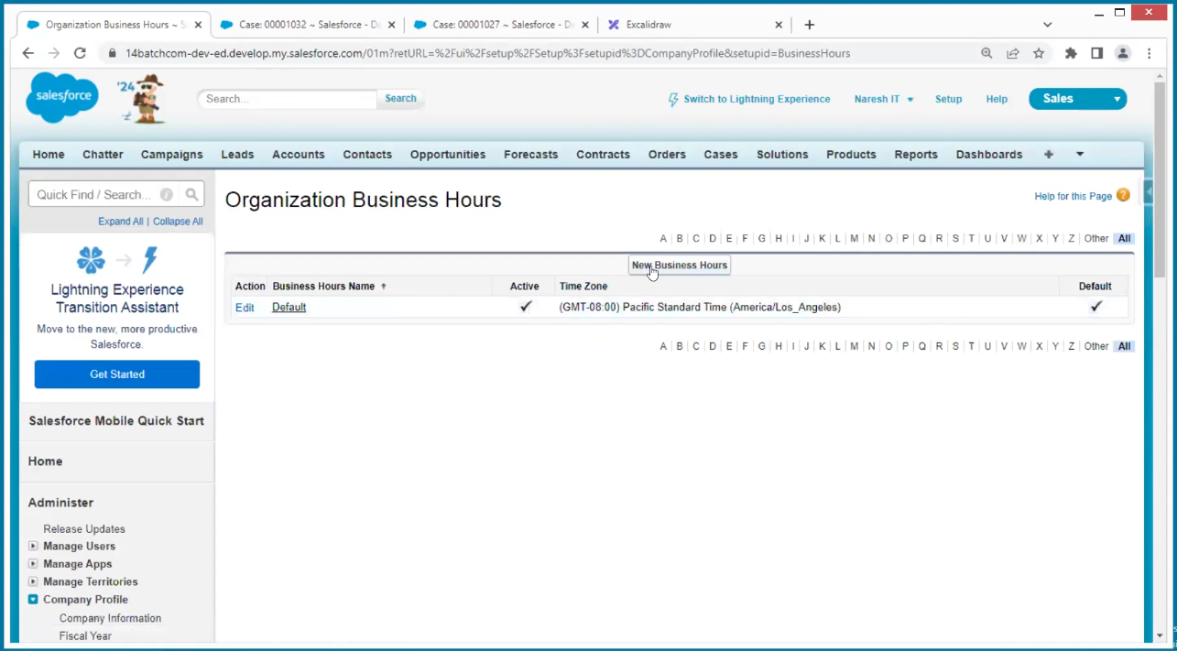

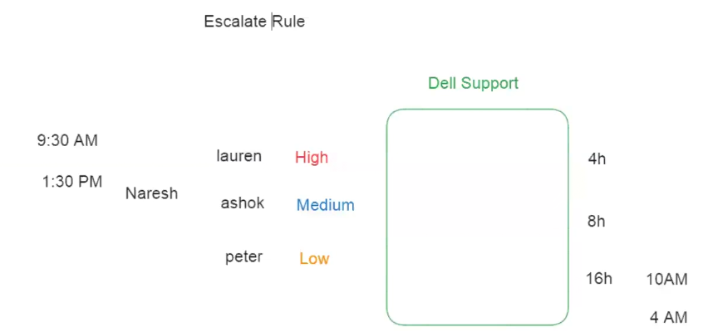

If the person is unable to solve the problem, then the case escalates too next

Escalation rules

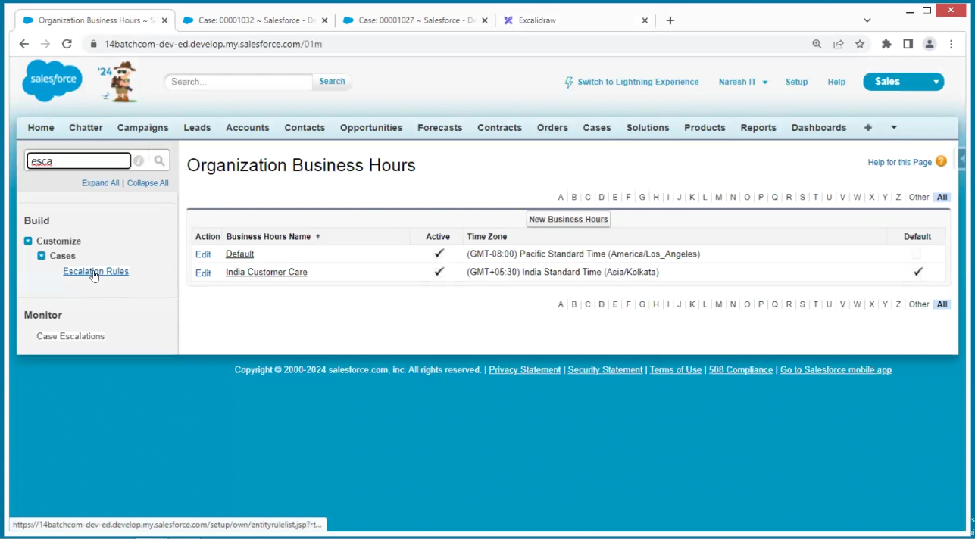

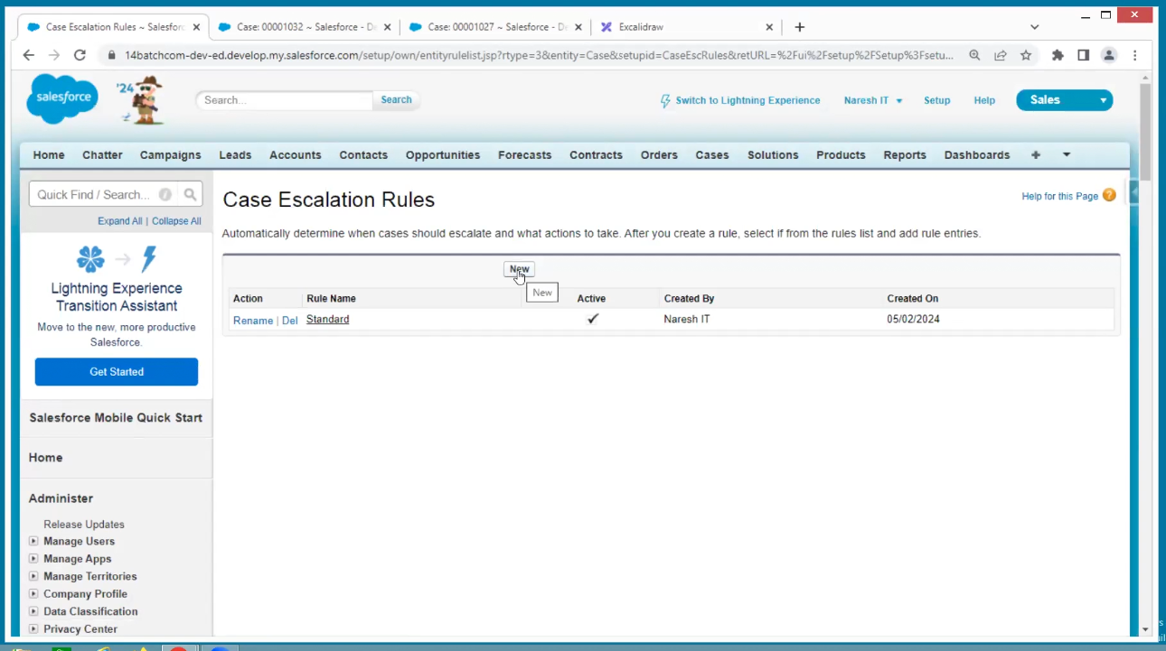

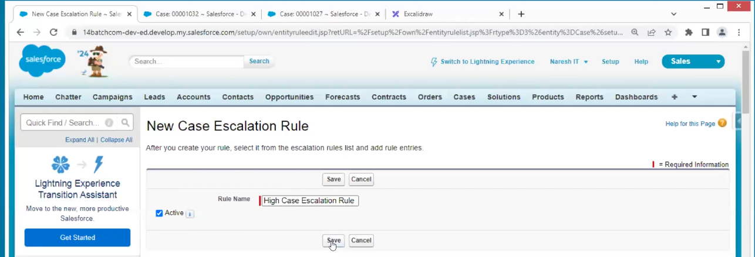

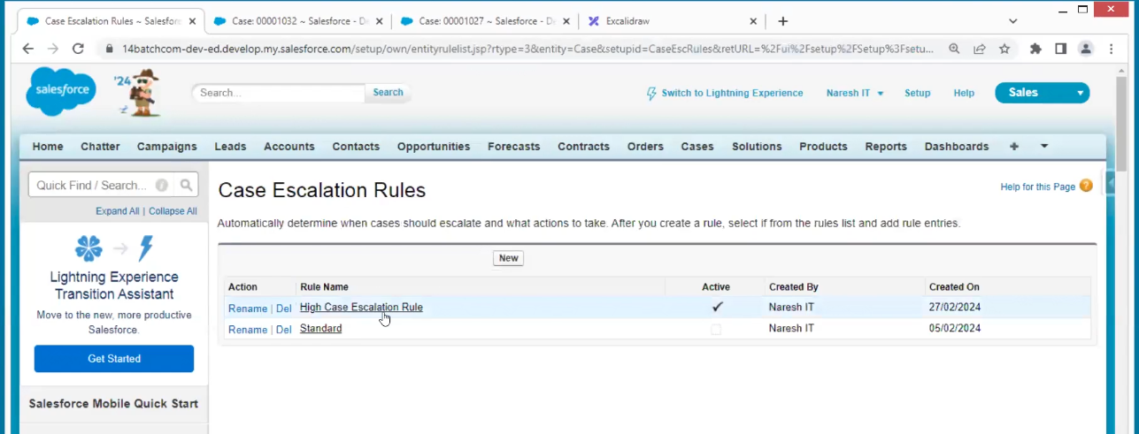

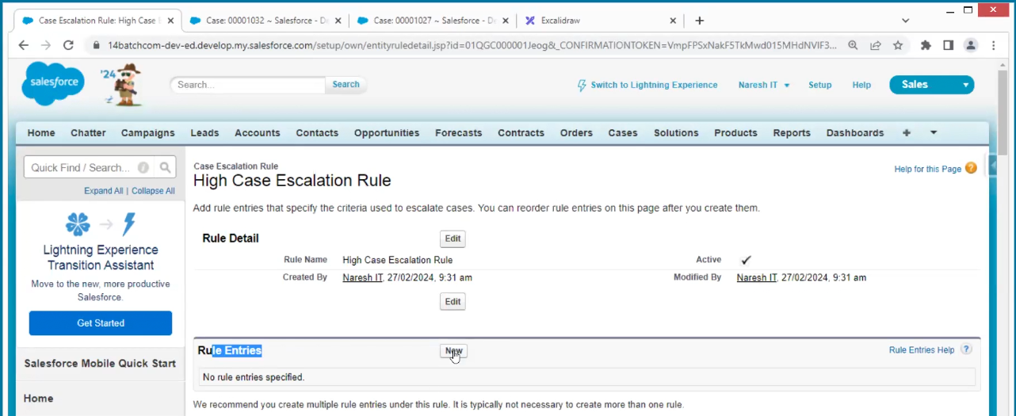

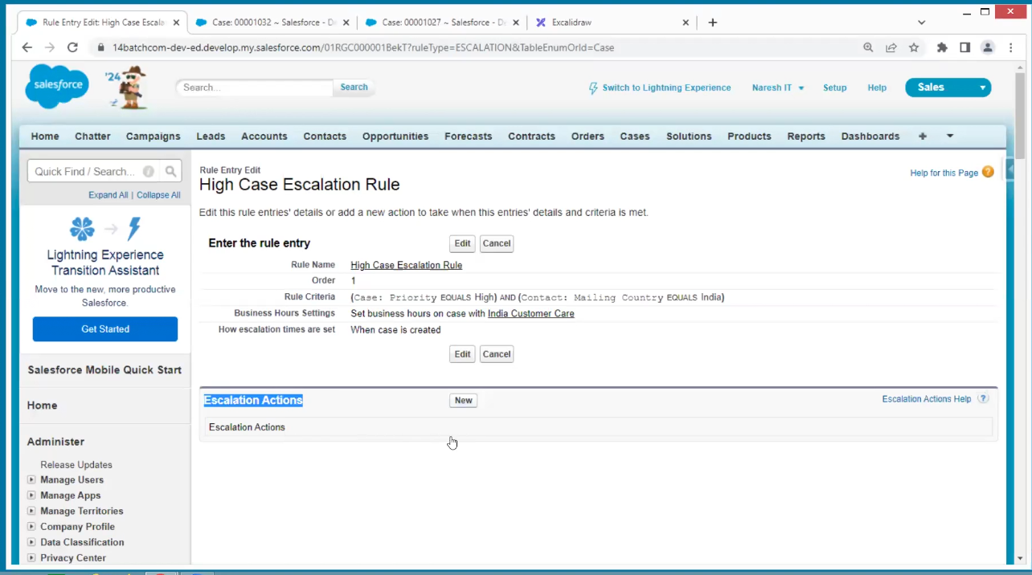

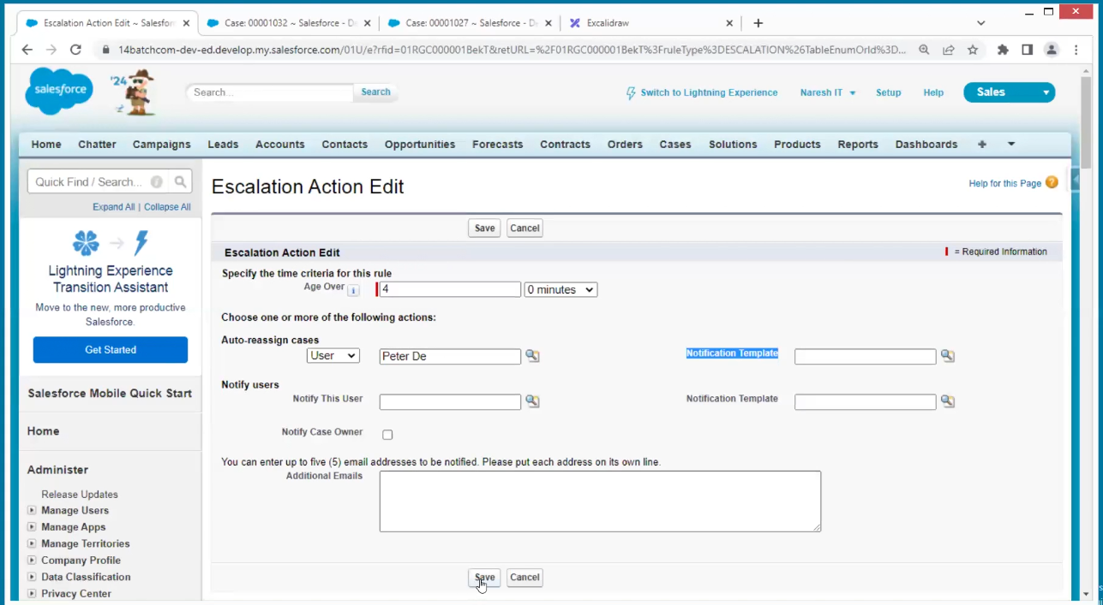

Create a new case of high and india

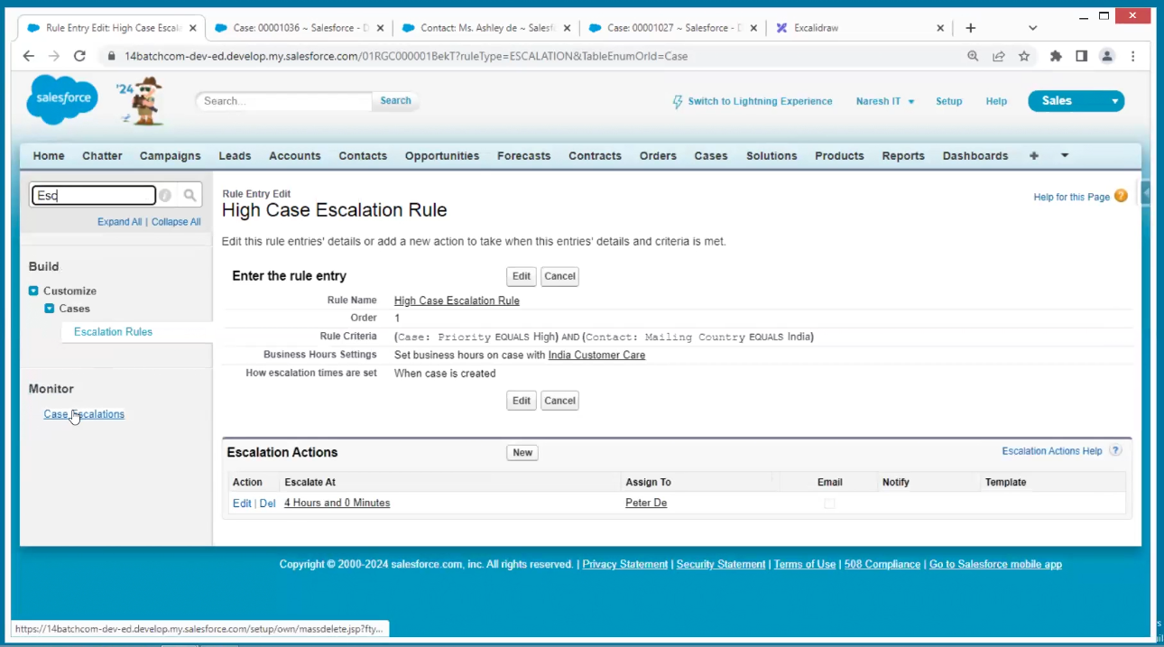

You can see here when new case is created automatically triggering here

Security

We need to give specific access to specific people

